Placement Cell Report 2021-22

- Dr. Ajmer Singh, Associate Professor, Deptt. Of Management Studies, CRSU , Jind,
Deliver online extension lectures on 25/01/2022 to the students of B.Sc. and B.com Final year students. Speaker gave various tips on the way to face Interview and preparing CVs for Interview.
- Dr. Ritu Rani, Assistant Professor, Deptt. Of Education, CRSU, Jind.
Deliver online extension lecture on Importance of Attitude in Life and Building Positive Attitude on 26/01/2022 to the students of B.Sc. Stream students. Purpose of this lecture was to help students in maintaining positivity in all walks of life.
- Dr. Prerna Dawar Saluja, Dean Academics & Professor, Geeta Engineering College, Panipat.
Deliver online extension lecture on Employability Enhancement and Career Guidance and Development on 27/01/2022 to final year students of the college. Main motto of this lecture was to aware the students about the employment opportunities available in the market today.
- Ms. Priyanka Dalal, Assistant Professor , Deptt. Of ECE, GJU, Hisar deliver online Extension Lecture
On Building Profile for better Career Opportunities and Role of Personality in Placement to the students of B.Sc. and B.Com. final year on 28/01/2022.
Speaker gave excellent tips on making good personality to the students.
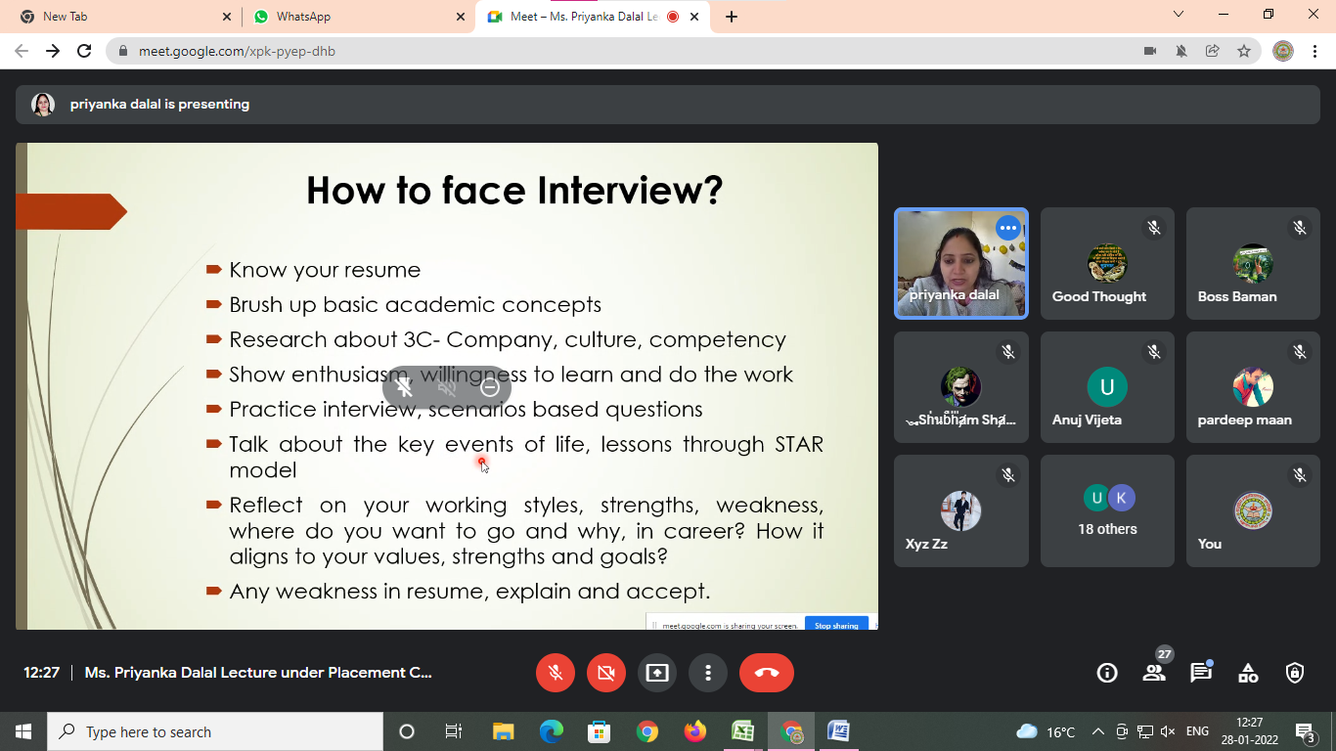

- Dr. Dinesh Verma, Assistant Professor , MCA, PIET, Samalkha(Panipat), delivered two online extension lectures
On Emerging Technologies to focus for better Placement and Success mantras for Placement on 29/01/2022. Speaker gave different mantras to the students for placements.

